7/9/21

I was able to install and run R and Rstudio without many issues. The tutorial provided was very helpful but I did run into a few errors. The most common issue I had was this error: Error in str(DatasetName): object 'DatasetName' not found. I found through googling that this is often an issue caused by typos when naming and calling either datasets or columns.

These are the predictions for my cars model: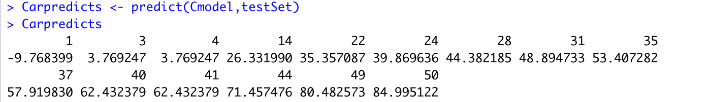

And these are my predictions for the iris model I created:

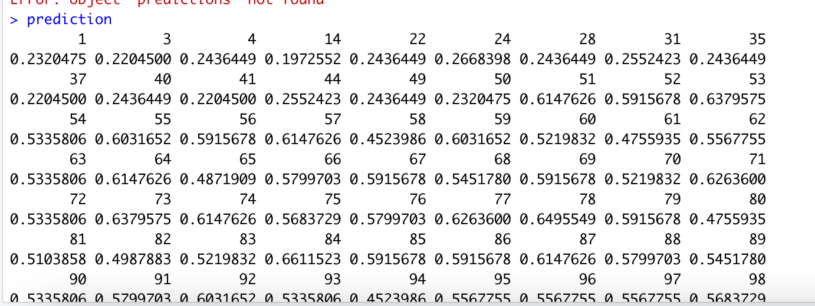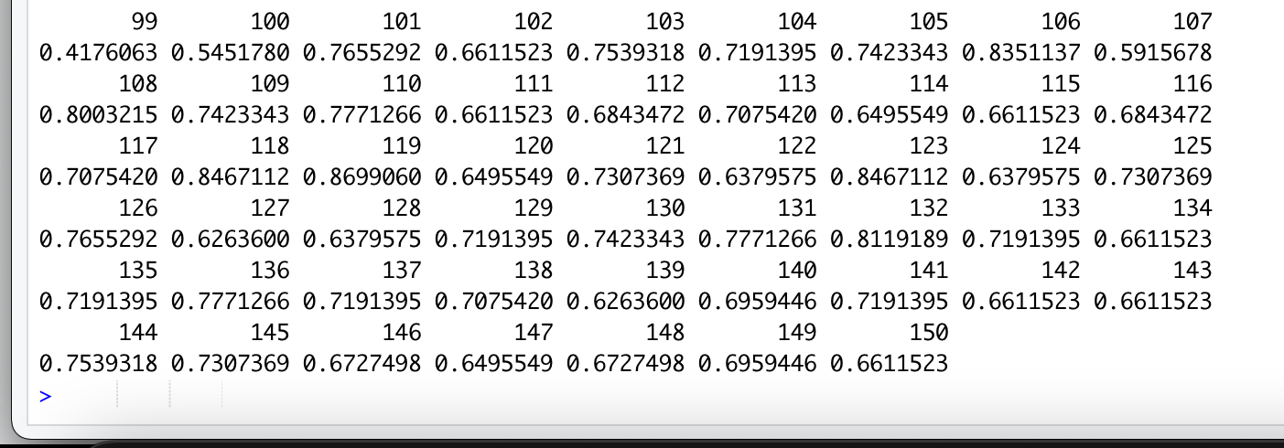

The biggest lesson that I took away from this exercise is that it is very important to keep the names for datasets and columns very straightforward. Also, it is important for all datasets to contain the correct datatypes. I would urge any other employees that are trying to learn R to read any and all documentation thoroughly. I also enjoy the easy way that R studio allows for you to save graphs that you have created, so I am including pictures of some of those below:

